DASC 5300: FOUNDATION OF COMPUTING

ASSIGNMENT 4

TITLE: PROGRAMMING ASSIGNMENT FOR RAILWAYS RESERVATION SYSTEMS

TEAM MEMBERS: SARTHAK HATWAR(1002176403)

ADITHYA VENKATESHA (100218991)

HONOR CODE

I pledge, on my honor, to uphold UT Arlington’s tradition of academic integrity, a tradition that  
values hard work and honest effort in the pursuit of academic excellence.  
I promise that I will submit only work that I personally create or that I contribute to group  
collaborations, and I will appropriately reference any work from other sources. I will follow the  
highest standards of integrity and uphold the spirit of the Honor Code

TASKS

TASK1: User input the passenger's last name and first name and retrieve all the trains they are booked on.

GUI of Task1:

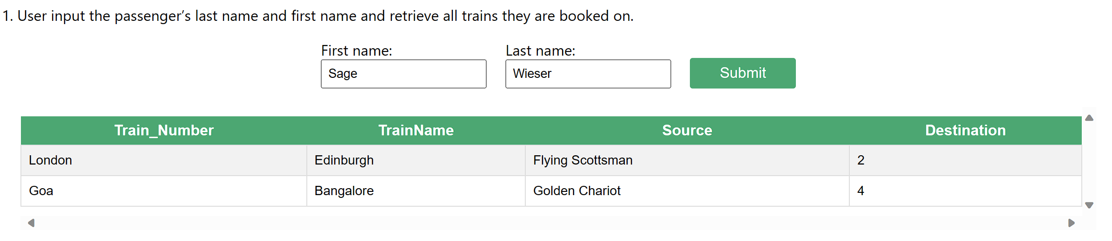

Description:   
1. Input areas are provided for users to enter the last and first names of the passenger.

2. A "Submit" button initiates the search process upon user interaction.

3. The UI presents a list showcasing all trains reserved for the specified passenger.

4. The design ensures a clear and user-friendly interface for efficient navigation and interaction.

TASK2 : User input the Date and list of passengers travelling on entered day with confirmed tickets displays on UI.  
  
GUI of Task2:

Description:  
1. Users can enter the desired date using an input field.

2. Upon submitting the date, the UI dynamically presents a list of passengers with confirmed tickets for the specified day.

TASK3 : User input the age of the passenger (50 to 60) and UI display the train information (Train Number, Train Name, Source and Destination) and passenger information (Name, Address, Category, ticket status) of passengers who are between the ages of 50 to 60.

GUI of Task3:

Description:  
1. User Input Section:

* Allows users to input the age of the passenger.
* Age is restricted to a range between 50 to 60.

2. Train Information Display:

* Upon submission, displays relevant train details.
* Information includes Train Number, Train Name, Source, and Destination.

3. Passenger Information Section:

* Presents passenger details meeting the age criteria.
* Includes Name, Address, Category, and Ticket Status.

TASK4 : List all the train name along with count of passengers it is carrying.

GUI of Task4:

Description:

1. The UI features a table to present the information, with columns for "Train Name" and "Passenger Count."

2. Each row in the table corresponds to a specific train, displaying its name and the corresponding count of passengers.

3. The UI design emphasizes clarity, making it easy for users to identify and understand the passenger count associated with each train.

TASK5 : Enter a train name and retrieve all the passengers with confirmed status travelling in that train.

GUI of Task5:

Description:

1. The UI includes a text input field where users can enter the train name.

2. After entering the train name, there's a button to initiate the retrieval process.

3. Below the input, a section displays the list of passengers with confirmed status for the specified train.

4. The UI provides a simple and intuitive design for users to input the train name and view the corresponding passenger information.

TASK6 : User Cancel a ticket (delete a record) and show that passenger in waiting list get ticket confirmed.

GUI of Task6:

Description:

1. The UI displays passenger reservation details, including a "Delete" button.

2. Upon clicking "Submit," the system removes the reservation record.

3. The UI instantly updates the status of the next passenger on the waiting list to "Confirmed," indicating successful ticket allocation.

Team contributions:

Backend:Sarthak Hatwar (10021764030

Frontend(GUI):Aditya VENKATESHA(100218991)